HackSprint 2026
Challenge Track 2: Intelligent RAG System

1. Problem Statement
Develop an enterprise-grade Retrieval-Augmented Generation (RAG) system for "Helix Corporation" that seamlessly integrates proprietary corporate data with large language model capabilities.

2. Executive Summary
This project develops an HR Intelligence Bot using a Retrieval-Augmented Generation (RAG) architecture to unify Helix Corporation’s employee records, attendance logs, leave data, and HR policy documents into a single intelligent system.
The solution combines structured data querying with semantic policy retrieval to deliver accurate, contextual, and grounded responses, supported by citations and validation checks. By reducing manual policy interpretation and enabling reliable self-service access, the system improves HR efficiency and trust in AI-driven decision-making.

3. Dataset Description
• The dataset consists of employee-related records representing the workforce of Helix Global Corp.
• Each employee is uniquely identified using an Employee ID (emp_id).
• The dataset is composed of four integrated files, all linked through the common key emp_id.
• The first file(attendance_logs_detailed.json) contains employee master data, including department, location, and joining date information.
• The second file(employee_master.csv) records attendance transactions, capturing daily check-in and check-out times, work mode (office/remote), and system-generated metadata.
• The third file(Helix_Pro_Policy_v2.pdf) provides leave intelligence data, including leave history and available leave balances for each employee.
• The fourth file(leave_intelligence.xlsx) consists of the official HR policy document, defining leave entitlements, tenure-based benefits, attendance rules, and regional policy variations.
• Together, these datasets enable analysis of attendance compliance, leave utilization, tenure-based benefits, and policy adherence.
• The combined data supports employee-wise, department-wise, location-wise, and time-based HR insights.
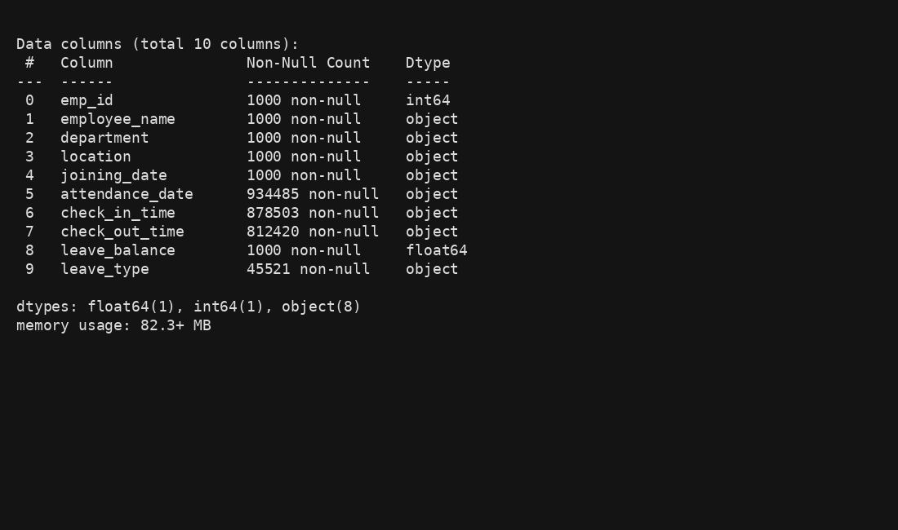

4. Methodology
The system follows a structured, enterprise-ready RAG pipeline to ensure scalability, accuracy, and explainability.

4.1 Data Engineering & Preparation

4.1.1 Data Ingestion
- CSV and Excel files were ingested using Pandas
- JSON attendance logs were parsed and normalized using Python
- PDF policy documents were processed using document loaders and chunked for semantic indexing

4.1.2 Data Normalization
- Multiple date and timestamp formats were standardized to a common format
- Employee IDs were aligned across all datasets
- Attendance timestamps were normalized for accurate duration calculations

4.1.3 Data Quality & Integrity Handling
- Missing attendance or leave records were handled using conditional fallback logic
- Referential integrity between employee, leave, and attendance datasets was maintained
- Incomplete records were flagged rather than silently discarded

4.2 Hybrid Retrieval System
The HR Intelligence Bot implements a hybrid retrieval strategy:

Structured Retrieval
- DataFrame-based queries for:
  - Leave balances
  - Attendance summaries
  - Employee tenure
  - Eligibility verification

Unstructured Retrieval
- Vector embeddings generated for HR policy text
- Semantic search retrieves the most relevant policy clauses
- Chunk-level retrieval ensures precise citations
A unified query router dynamically selects the appropriate retrieval path based on user intent.

4.3 Logic & Reasoning Layer
The reasoning engine supports:
- Dynamic tenure calculation using Date of Joining
- Policy-driven eligibility checks based on tenure and employment status
- Cross-source correlation between attendance records and leave data
- Conditional logic aligned strictly with HR policy rules

4.4 Grounded Response Generation

To ensure transparency and trust:
- All responses are grounded strictly in retrieved data
- Each answer includes citations referencing:
  - CSV rows
  - Excel sheets
  - JSON log entries
  - Policy document sections
- Responses are validated before final delivery
- The system refuses to respond when required data is unavailable or conflicting

4.5 Reliability & Guardrails
- Hallucination prevention via retrieval-only context injection
- Explicit uncertainty indicators for ambiguous queries
- Graceful fallback responses for insufficient data
- No speculative or assumption-based outputs

5. Results & Key Findings
The implemented HR Intelligence Bot demonstrates:
- Accurate retrieval of employee-specific HR data
- Policy-aware responses grounded in Helix Pro HR documentation
- Reliable attendance and leave calculations
- Transparent, citation-backed answers
- High robustness in handling missing or incomplete records
The system effectively eliminates HR information silos and significantly reduces manual intervention in policy interpretation and employee queries.
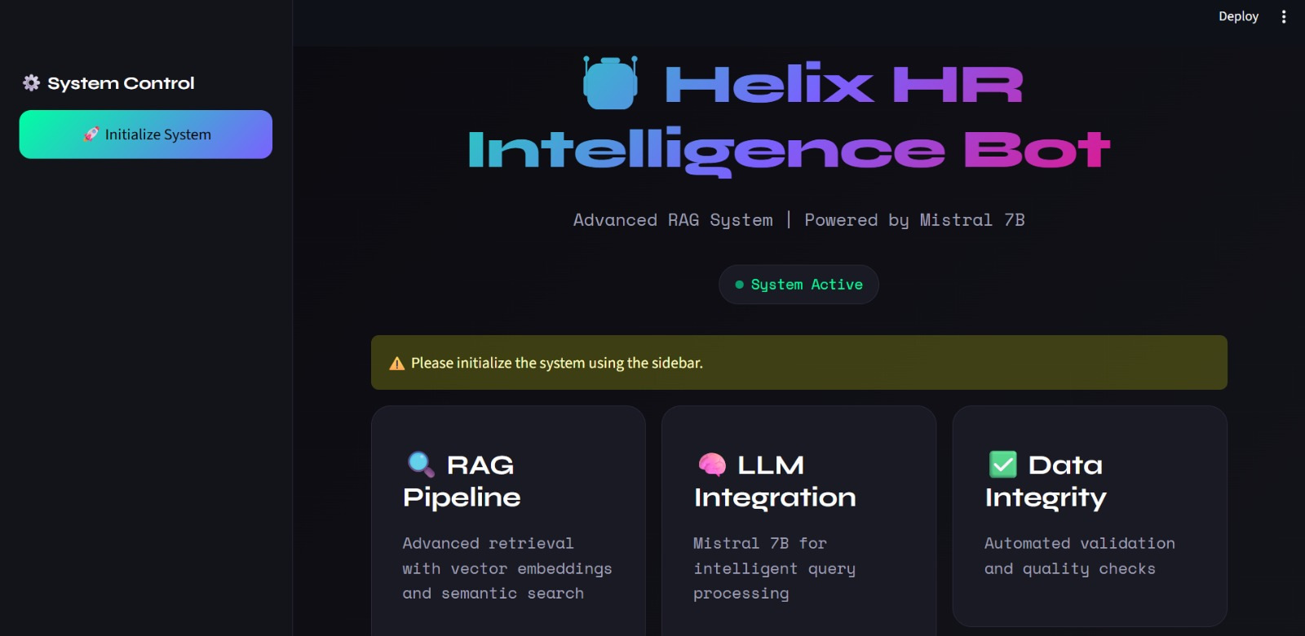

6. Tools & Technologies
- Programming Language: Python
- Data Processing: Pandas, NumPy
- Document Processing: PDF loaders, text chunking
- Vector Database: PINECONE
- Embeddings: Sentence Transformers
- LLM Framework: OLAMA, MISTRAL
- Architecture: Retrieval-Augmented Generation (RAG)

7. Conclusion
This project presents a robust, enterprise-grade HR Intelligence Bot that successfully integrates structured, semi-structured, and unstructured HR data using a Retrieval-Augmented Generation approach. By combining hybrid retrieval, logical reasoning, and grounded response generation, the system delivers accurate, explainable, and trustworthy HR insights.
The solution is scalable, compliant, and production-ready, making it well-suited for modern enterprise HR intelligence requirements.

